Top-tier Energy Regulators meet in Tbilisi
to spur investments in renewable energy
— PRESS RELEASE —

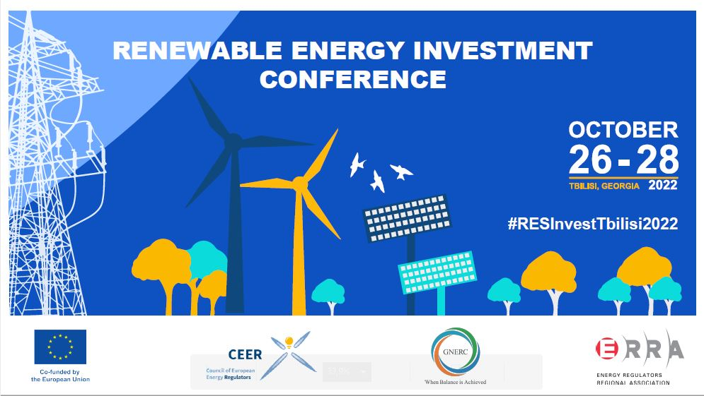
Tbilisi, 26 October 2022 – The Council of European Energy Regulators (CEER) on behalf of the European Commission’s EU4Energy Programme – “Promoting the Clean Energy Transition in the Eastern Partnership Countries”, the Energy Regulators Regional Association (ERRA) and Georgian National Energy and Water Supply Regulatory Commission (GNERC) are welcoming more than 200 conference delegates in Tbilisi, Georgia for the first Renewable Energy Investment Conference.
The three-day event – co-funded by the European Union – brings together energy regulators and high-level policymakers to find ways forward to accelerate the energy transition and catalyse investments in renewable energy projects in Europe, Eastern Partnership countries and beyond.
The Conference will shed light on how to best facilitate large-scale, sustainable investments in the energy sector across the globe and identify the key elements to secure a positive investment climate as the energy crisis unfolds while staying on target to reach the ambitious goals set in the Paris Agreement and the UN’s Climate Change Conferences. Actions proposed to attract significant financial resources will include creating new technology frameworks and enhancing capacity-building among different state and private actors.
A keynote address by the Vice Prime Minister of Georgia, Levan Davitashvili, will address the significance of renewable energy investments for the clean energy transition and diversification of energy sources.
In his video address, EU Commissioner for Neighbourhood and Enlargement, Mr Oliver Várhelyi stressed the importance of energy transition for achieving the goals of the Paris Agreements and moving away from fossil fuels towards renewable energies. Investing in renewable energy connectivity and energy security is the key to a resilient and prosperous future for the EU and its neighbours.
Conference sessions will allow for a detailed analysis of factors that incentivise investments in renewable energy sources – such as the role of regulation and the needed degree of its stability, sources of financing, the availability of various technologies and operation schemes, the evaluation of renewable projects by private investors, state energy strategy, and consumer-related issues. Theoretical presentations will be underpinned by regulatory case studies on renewable investment projects with a practical set of lessons learnt from the process.
The Conference will also celebrate 25 years of independent regulation in Georgia since the foundation in 1997 of the Georgian National Energy and Water Supply Regulatory Commission (GNERC), for which CEER and ERRA congratulate GNERC.

For the detailed conference programme please refer to: https://www.res-investmentconference.com/en/home
Media Contacts:
 | Council of European Energy Regulators (CEER) | Energy Regulators Regional Association (ERRA) | Georgian National Energy and Water Supply Regulatory Commission
 | Mr Charles Esser | Ms Krisztina Kasza | Ms Ketevan Berikashvili
Tel. | +32 2 788 7336 |  | +995 577310011
Email: | charles.esser@ceer.eu | secretariat@erranet.com | k.berikashvili@gnerc.org
Website: | www.ceer.eu | https://erranet.org/ | www.gnerc.org
Twitter: | twitter.com/CEERenergy | https://twitter.com/ErraNews | https://twitter.com/Gnerc_
LinkedIn: | https://www.linkedin.com/com pany/council-of-european- energy-regulators/ | https://www.linkedin.com/company/energy-regulators-regional-association/ | https://www.linkedin.com/company/%E1%83%A1%E1%83%94%E1%83%9B%E1%83%94%E1%83%99%E1%83%98-gnerc/
Facebook: | https://www.facebook.com/CEERenergy | https://www.facebook.com/erra.secretariat | https://www.facebook.com/GNERC
About ERRA
The Energy Regulators Regional Association (ERRA) is a voluntary organization comprised of independent energy regulatory bodies primarily from the Central European and Eurasian region, with Associates from Asia, Africa, the Middle East, North and South America. There are now 48 members working together in ERRA. The Association’s main objective is to increase exchange of information and experience among its members and to expand access to energy regulatory experience around the world. Visit us at www.erranet.org for more information.

About CEER

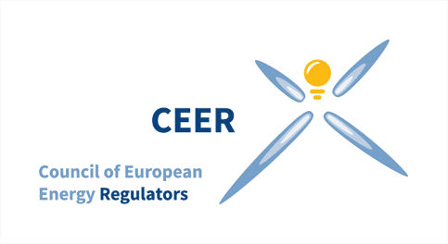CEER is the voice of Europe's national energy regulators at EU and international level. The overall aim of the Council of European Energy Regulators (CEER) is to facilitate the creation of a single, competitive, efficient and sustainable internal market for gas and electricity in Europe. The CEER acts as a platform for cooperation, information exchange and assistance between Europe's national energy regulators and is their interface at EU and international level. The Council of European Energy Regulators (CEER) represents 39 energy regulatory authorities, comprising 30 Members and 9 Observers. The Georgian National Energy and Water Supply Regulatory Commission (GNERC) has been an Observer of CEER since 2017. Visit us at www.ceer.eu for more information.

